# Lab: AJAX & jQuery AJAX

Problems for in-class lab for the [“JavaScript Applications” course @ SoftUni](https://softuni.bg/courses/javascript-applications). Submit your solutions in the SoftUni judge system at <https://judge.softuni.bg/Contests/1568/Lab-AJAX>.

## XHR (XmlHttpRequest)

Your task is to **write** a JS function that **loads** a GitHub repository **asynchronously with AJAX**.

* Create a file called **"**xhr.js**"** and write the function loadRepos()in it. If you take a closer look at the provided skeleton, you will see that this file is linked in the head section.
* **Create** an instance of XmlHttpRequest and attach an onreadystatechange event to it.
* Replace the text content of adiv element with id**="**res**"** with the value of the responseText property of the request when the readyState attribute reaches a value of **4** (it is ready).
* **Do NOT format** the response in any way. Submit your loadRepos() function.

Read more about **XmlHttpRequest** [**here**](https://developer.mozilla.org/en-US/docs/Web/API/XMLHttpRequest/open).

### Skeleton

|  |
| --- |
| **xmlHttpRequest.html** |
| <!DOCTYPE html>  <html lang="en">  <head>  <meta charset="UTF-8">  <title>XmlHttpRequest Example</title>  <script src="xhr.js"></script>  <style>  @import url(https://fonts.googleapis.com/css?family=Open+Sans);  body {  font-family: "Open Sans", serif;  }  button {  background-color: #4caf50;  color: white;  padding: 14px 20px;  margin: 8px 0;  border: none;  border-radius: 4px;  cursor: pointer;  }  button:hover {  background-color: #45a049;  }  </style>  <*/*head>  <body>  <button onclick="loadRepos()">Load Repos</button>  <div id="res"></div>  </body>  </html> |

### Example

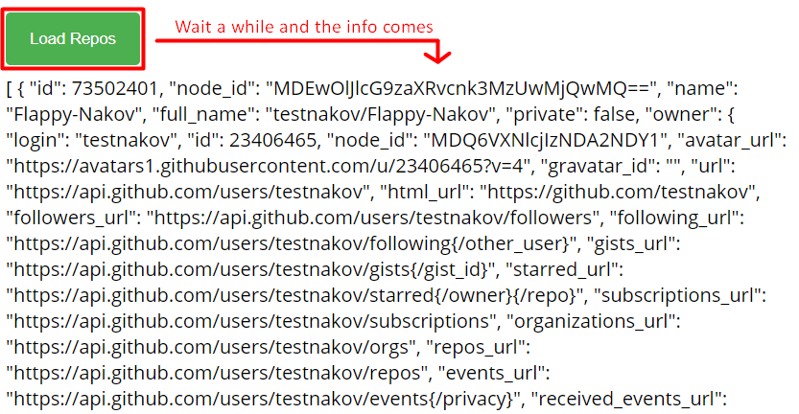

## AJAX Load

Use **jQuery** to **write** a JS function that loads an online resource into a div with id="text"**.** Make a request to "text.html" and replace the target div element's content with the returned **HTML**. Create the files ajax-load.html and text.html and place them in the same folder, so that your script can find them.

Submit your loadTitle() function.

### Skeleton

|  |
| --- |
| **ajax-load.html** |
| <!DOCTYPE html>  <html lang="en">  <head>  <meta charset="UTF-8">  <title>AJAX Load Example</title>  <script src="https://code.jquery.com/jquery-3.1.1.min.js"></script>  **<style>**  **@import url(https://fonts.googleapis.com/css?family=Open+Sans);**  **body {**  **font-family: "Open Sans", serif;**  **}**  **button {**  **background-color: #4caf50;**  **color: white;**  **padding: 14px 20px;**  **margin: 8px 0;**  **border: none;**  **border-radius: 4px;**  **cursor: pointer;**  **}**  **button:hover {**  **background-color: #45a049;**  **}**  **</style>**  </head>  <body>  <div id="text">  <h1>AJAX jQuery.load()</h1>  <button onclick="loadTitle()">Load Title</button>  </div>  </body>  </html> |

|  |
| --- |
| **text.html** |
| <h1>Voilla!</h1>  <p>I am a text loaded with AJAX request</p> |

|  |
| --- |
| **ajax-load.js** |
| function loadTitle() {  *// TODO*  } |

### Example

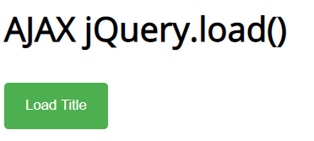 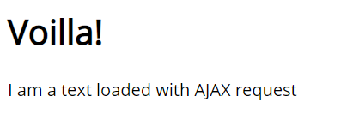

## Github Repos

Your task is to **write** a JS function that **executes** an **AJAX** request with **jQuery** and loads all user **GitHub repositories** by a given username (taken from an input field with id="username") into a **list** (each repository as a **list-item**) with id="repos". Use the properties full_name and html_url of the returned objects to create a link to each repo's GitHub page. If an **error** occurs (like 404 "Not Found"), **append** to the list a list-item with **text** "Error" instead. Clear the contents of the list before any new content is appended. See the **highlighted lines** of the skeleton for formatting details of each list item. Submit your loadRepos() function that should be created in a file called "loadRepos.js".

### Skeleton

|  |
| --- |
| **github-repos.html** |
| <!DOCTYPE html>  <html lang="en">  <head>  <meta charset="UTF-8">  <title>GitHub Repos</title>  <script src="https://code.jquery.com/jquery-3.1.1.min.js"></script>  <script src="loadRepos.js"></script>  **<style>**  **@import url(https://fonts.googleapis.com/css?family=Open+Sans);**  **body {**  **font-family: "Open Sans", serif;**  **}**  **button {**  **background-color: #4caf50;**  **color: white;**  **padding: 14px 20px;**  **margin: 8px 0;**  **border: none;**  **border-radius: 4px;**  **cursor: pointer;**  **}**  input[type=text] {  padding: 12px 20px;  margin: 8px 0;  display: inline-block;  border: 1px solid #ccc;  border-radius: 4px;  }  </style>  </head>  <body>  GitHub username:  <input type="text" id="username" value="k1r1L" />  <button onclick="loadRepos()">Load Repos</button>  <ul id="repos">  <li>  <a href="*{repo.html_url}*">  *{repo.full_name}*  </a>  </li>  </ul>  </body>  </html> |

### Example

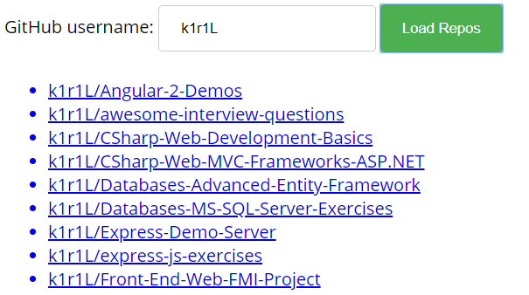

## Phonebook

Use **Firebase** and **jQuery** to create a simple phonebook app. The user should be able to see all contacts, **loaded** from the server, **create** a new contact and **delete** any of the contacts. Use the lecture presentation for detailed instructions on this task. Place your code in a file called "phonebook.js", as shown in the skeleton. This task is not evaluated by Judge, it is for practice only.

### Skeleton

|  |
| --- |
| **phonebook.html** |
| <!DOCTYPE html>  <html lang="en">  <head>  <meta charset="UTF-8">  <title>Phonebook</title>  <script src="https://code.jquery.com/jquery-3.1.1.min.js"></script>  **<style>**  **@import url(https://fonts.googleapis.com/css?family=Open+Sans);**  **body {**  **font-family: "Open Sans", serif;**  **}**  **button {**  **background-color: #4caf50;**  **color: white;**  **padding: 14px 20px;**  **margin: 8px 0;**  **border: none;**  **border-radius: 4px;**  **cursor: pointer;**  **}**  **input[type=text] {**  **padding: 12px 20px;**  **margin: 8px 0;**  **display: inline-block;**  **border: 1px solid #ccc;**  **border-radius: 4px;**  **}**  **</style>**  </head>  <body>  <h1>Phonebook</h1>  <ul id="phonebook"></ul>  <button id="btnLoad">Load</button>  <h2>Create Contact</h2>  Person: <input type="text" id="person" />  <br>  Phone: <input type="text" id="phone" />  <br>  <button id="btnCreate">Create</button>  <script src="phonebook.js"></script>  </body>  </html> |

### Example

